Here are 3 activities to practice health literacy strategies for clear communication. You will have a few minutes to work on each activity, followed by group discussion. The presenters will ask if attendees want to share their answers.

1 – Assess purpose and audience
Instructions:

Working on your own, review the brochure and answer
these 3 questions:

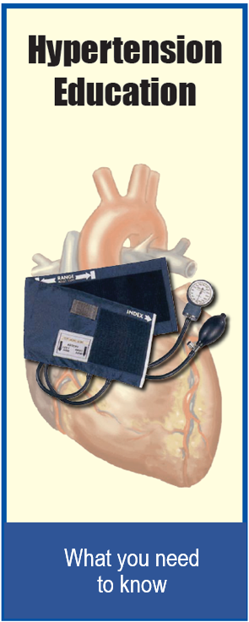
What is the purpose of this brochure?

Who is the intended audience?

- How could you change this brochure to better show the purpose and audience?

2 – Write clear, direct sentences
Instructions:
Strategies:
- Replace long, complex words with shorter words
- Write the way you speak
- Convert passive voice to active voice
- Read the 2 passages below.
- Rewrite each sentence so it’s shorter and
more direct.

Passage 1:
To ensure that all stakeholders positively enter into engagement efforts that effectively drive health care innovation based on patient and caregiver insights, the National Health Council has created a toolbox, the Fair-Market-Value (FMV) Calculator for Patient-Engagement Activities, to support sponsor-patient engagement.

Revision:

Passage 2:

The Company will ensure transparency of the payments made to the Patient Consultant in accordance with applicable local and international laws, regulations and Codes of Conduct, applicable to the pharmaceutical industry. This may involve the publication on its website or the communication to third parties about payments made under this Agreement, including project costs as well as fees and expenses that the Company has covered.

Revision:

3 – Give clear action steps

Instructions:
- Read the paragraph below.
- Revise the text into clear, specific action steps.

To join this study, you will need to review and sign a paper called an informed consent form. This form describes the study in detail, including the risks and benefits. Please fully read the entire form and have all of your questions answered by the study team. You can also discuss joining the study with your family and friends. When you have done this, you can decide whether or not you will sign the form and join the study.
Revision:

