Here are 2 activities to practice health literacy strategies for clear science communication. You will have a few minutes to work on each activity, followed by group discussion. The presenters will ask if attendees want to share their answers.

1 – Use clear data visualization
Instructions:

Working on your own, look at the 3 pieces of data below and decide which type of graph or chart would be the best way to present each.
Graph types:
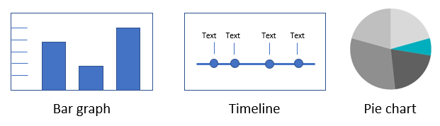

142 participants took trial treatments – 52 from Germany, 50 from France, and 40 from Italy.

Up to 3 weeks before taking the trial treatment, participants had physical exams and other health tests. Participants took the trial treatment as an injection for 36 weeks. After treatment ended, the trial staff followed up with participants every week for 10 weeks.

- In this clinical trial, the average size of tumors for participants in both treatment groups was about 3 cm before treatment. After 6 months of treatment, the participants who took the trial treatment had their tumors shrink more than participants who took the standard treatment. The average tumor size for participants who took the trial treatment was 1 cm. The average tumor size for participants who took the standard treatment was 2 cm.
2 – Write clear descriptions
Instructions: For this activity, choose 1 of these 2 options to work on.
Option 1: Read the following clinical trial description. Then, apply health literacy strategies to write a revision that might be easier for a patient to understand.
Clinical trial description:
This was a randomized group trial to evaluate efficacy and safety of ABC12R 5 mg compared to placebo for glycemic control, administered as oral doses for 24 weeks in 706 patients with type 2 diabetes.

Option 2: Think about an example of complex communication you came across in your work. This could be a paragraph of text, a social media post, or a subject you struggled to clearly communicate to your audience. Then, use the health literacy strategies you learned about to revise it.

